National Hive Stand Assembly Instructions



**Essential tools:**

Measuring Tape

Pencil

Hammer

Phillips Screwdriver

Punch

**Kit consists of:**

A: 1x Hive Stand Front (Alighting Board)

B: 1x Hive Stand Back

C&D: 2x Hive Stand Sides

10x 1.5” Sherardised Nails

**With legs:**

8x40mm Wood Screws

4x5” Splayed Legs

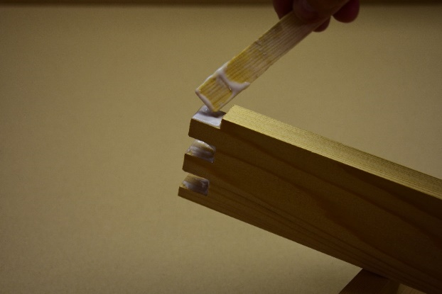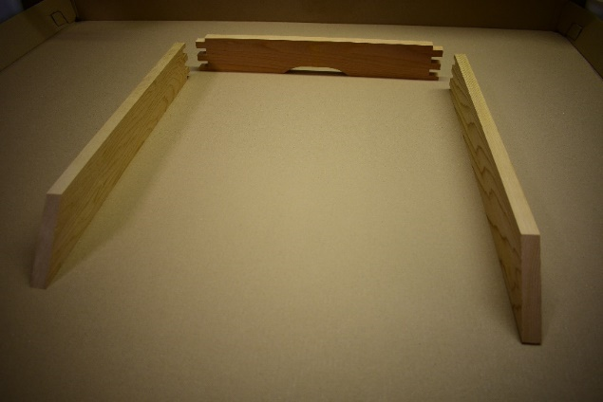

**B**

**D**

**C**

Apply your chosen glue to the joints.

Take the three jointed pieces and lay out as shown.

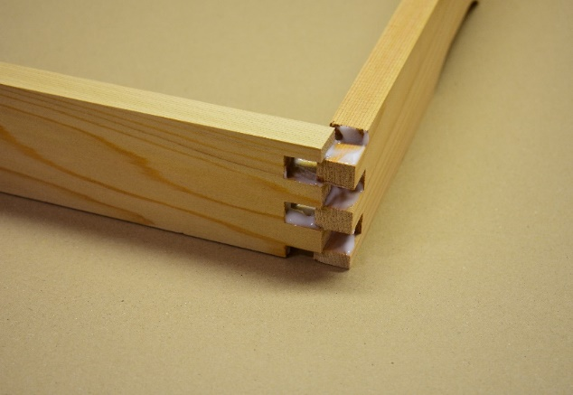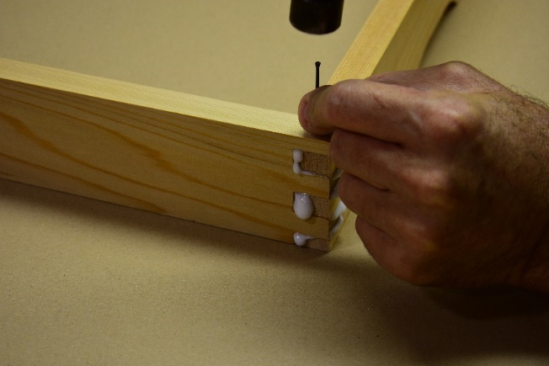

Assemble the two joints holding a piece in each hand move the joints back and forth whilst applying pressure from each side until the joints are fully home.

Ensure the joints are flush and then nail down through the joints top and bottom.

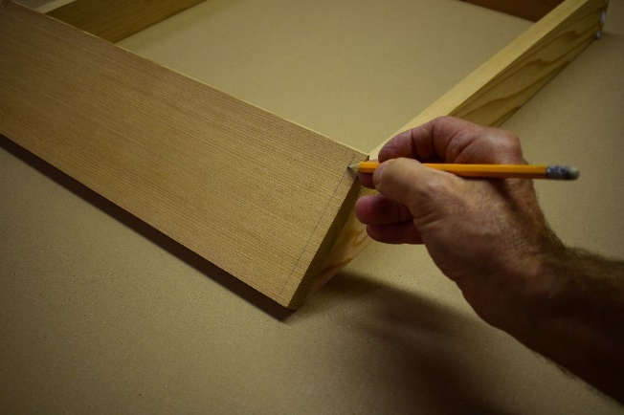

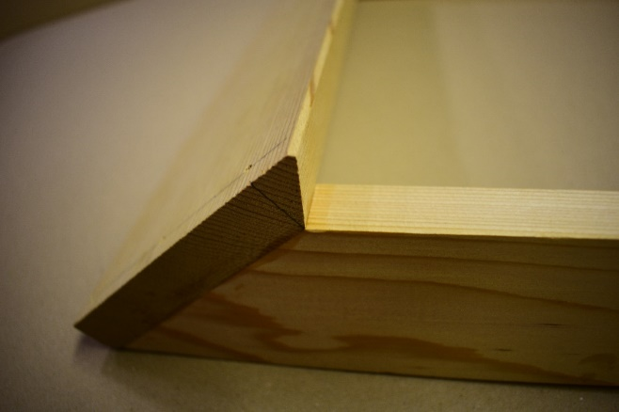

**A**

Note the orientation of the alighting board to the side piece. This forms a right angle for your floor to line up too.

Use a pencil to mark the landing board in line with the middle of the side piece on each end. This line should be 10mm or 3/8” from the edge.

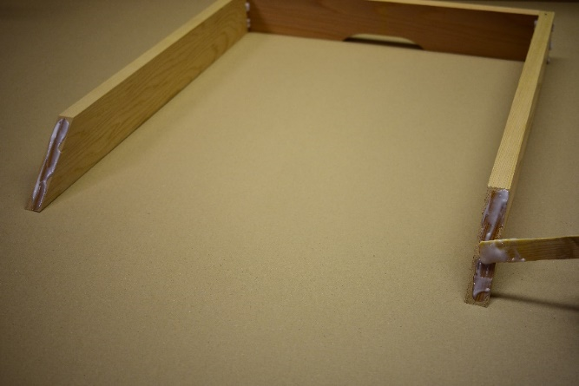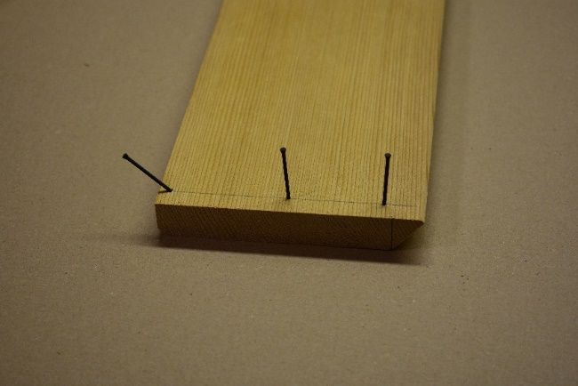

Apply glue to the two front pieces.

Hammer three nails in as shown making sure that the bottom nail is angled 45 degrees. The top nail should be 25mm or 1” down from the top edge to ensure it nails into the side piece correctly.

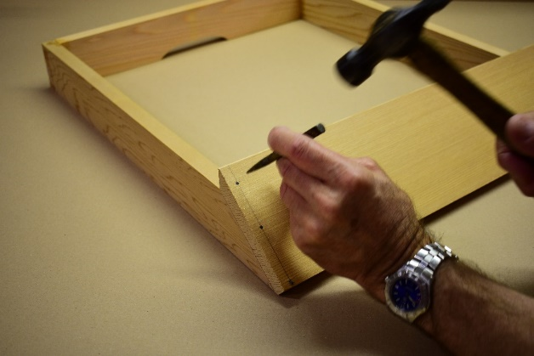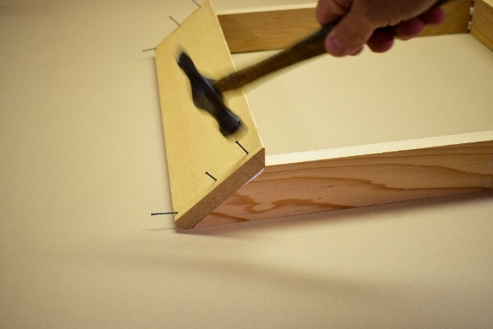

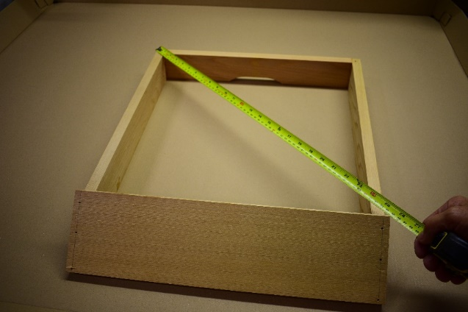

Use a punch to countersink the nail heads on the front piece and the four corner nails in the finger joints.

Nail on the front piece as shown.

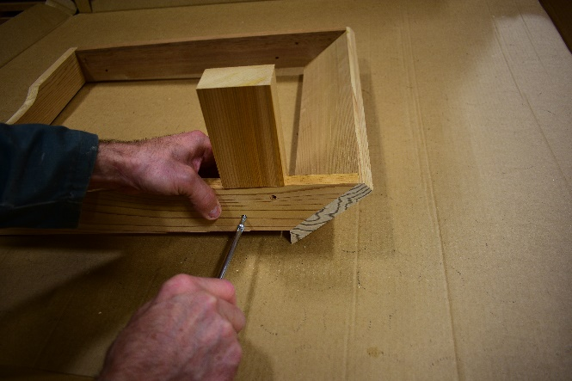

Add the legs to the inside of the stand. Secure with 8x40mm Wood Screws.

Finally check that the stand is square. The diagonal angles should measure the same, adjust if necessary, by pressing from the corners across the longest diagonal.

**You can watch a full video on how to assemble your hive stand here; beekeeping.co.uk/pages/how-to-videos.**