Frame Assembly Instructions



**Essential tools:**

Hammer

Stanley Knife

**Kit consists of:**

x1 Top bar

x2 Side bars

x2 Bottom bars

1 Sheet of wax foundation

Frame nails

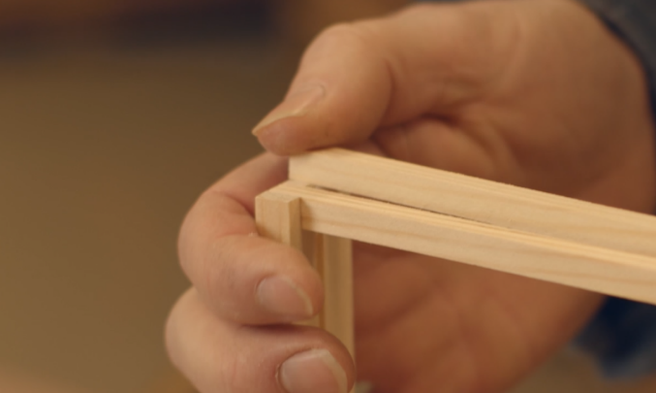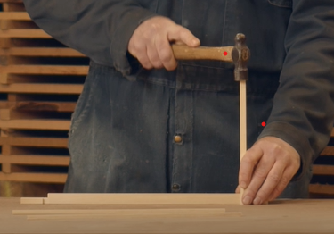

Carefully slot the two bottom bars in. Tap them in with the hammer.

Use your hammer to tap the side bars into the ends of the top bar. Make sure the groove is facing inwards.

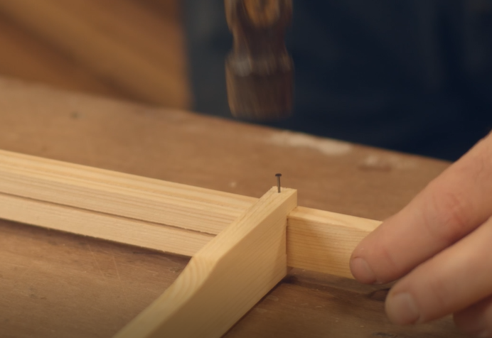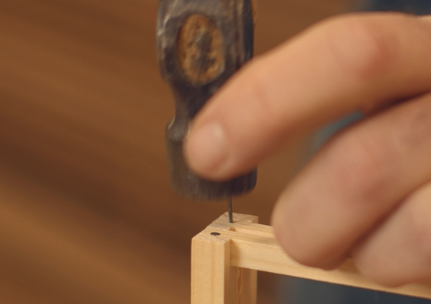

Now it’s time to nail the frame into place. Start with the bottom bars.

Nail the side bar into the top bar

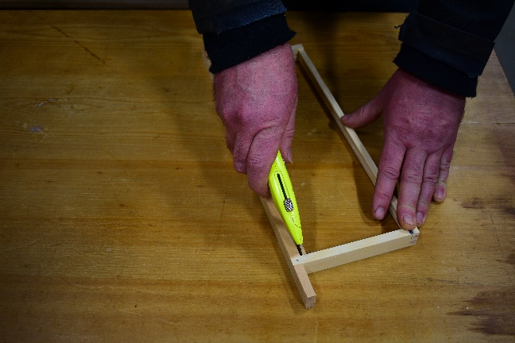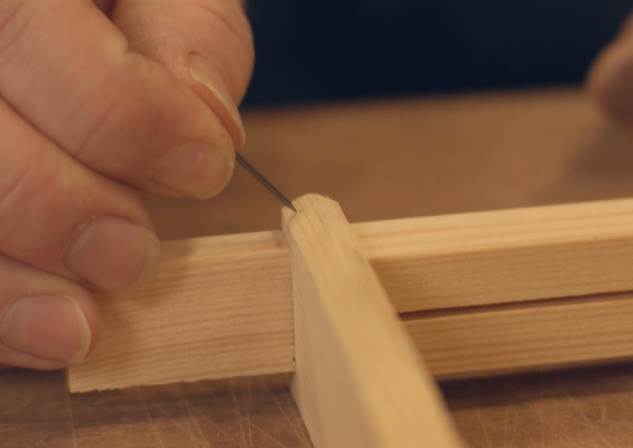

­­

Nail the side bars into the top bar at a slight angle

Inside the top bar is a wedge piece of wood. Pop this out, use the Stanley knife if needed.

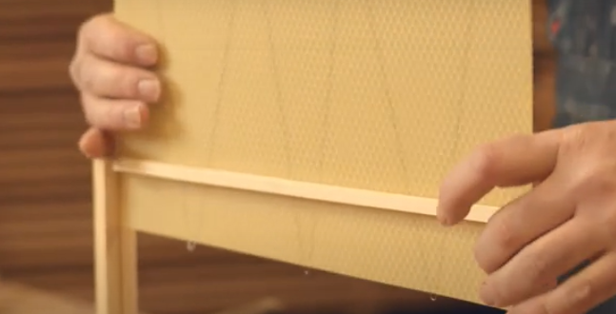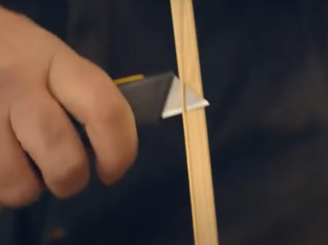

You may have to clean some of the wood off to make sure the wax sits in properly.

With the 3 loops of wire facing down, slot in your sheet of wax.

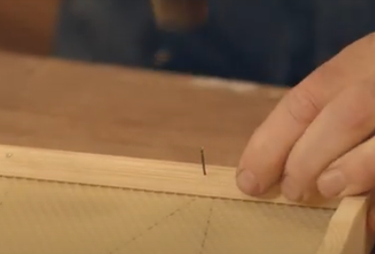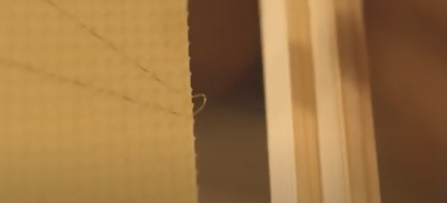

**You can watch a full video on how to assemble your frames here beekeeping.co.uk/pages/how-to-videos.**

Just before it reaches the bottom, bend the 3 loops over to sit in the recess. Take the wedge, and fix it in.

Place the nails at an angle heading to the back edge.